**Web Programming**

**(LAB Session-14)**

**Working with PHP, MySQL and AJAX**

* **In the previous lab, we had developed admin panel for a university website to enter result into database. In this LAB, we are going to develop client-side interface for the same.**

1. **Develop a client web page where student will enter his/her enrolment number to check the result.**
2. **When student clicks on “Check My Result”, client-side html page will create an XMLHttpRequest object which will query a page on the server by passing enrolment number of the student as query string.**
3. **The enrolment number will be passed to a php page on the server which will query the database for the result.**
4. **If the result is found, the php page will construct a table and send the result of the student back to the client page as response of the AJAX query as per below screenshot.**
5. **If the result is not found from the database, php page will send back an error message which will be displayed on the result page as per below screenshot.**

CODE:

**Index.php**

**<html>**

**<head>**

**<title>GTU Result</title>**

**<meta charset="utf-8">**

**<meta name="viewport" content="width=device-width, initial-scale=1">**

**<link rel="stylesheet" href="https://maxcdn.bootstrapcdn.com/bootstrap/3.3.7/css/bootstrap.min.css">**

**<link rel="stylesheet" href="https://maxcdn.bootstrapcdn.com/font-awesome/4.7.0/css/font-awesome.min.css">**

**<script src="https://ajax.googleapis.com/ajax/libs/jquery/3.3.1/jquery.min.js"></script>**

**<script src="https://maxcdn.bootstrapcdn.com/bootstrap/3.3.7/js/bootstrap.min.js"></script>**

**<style type="text/css">**

**div{**

**width: 40%;**

**margin-top: 20px;**

**border-radius: 15px;**

**}**

**input{**

**margin-top: 10px;**

**}**

**</style>**

**</head>**

**<body>**

**<center>**

**<div class="well">**

**<h1>Result</h1>**

**<form id="myform">**

**<input class="form-control" placeholder="Enter your Enrollment No" type="text" id="enroll" ><br><br>**

**<input class="btn btn-success form-control" type="submit" name="" id="Submit" value="Submit" style="opacity: .8">**

**</form>**

**</div>**

**<div id="restbl">**

**</div>**

**</center>**

**<script type="text/javascript">**

**var form = document.getElementById("myform");**

**form.addEventListener("submit", function(e) {**

**e.preventDefault();**

**var enroll = document.getElementById("enroll").value;**

**var disp = document.getElementById("restbl");**

**if (enroll != null && enroll != "") {**

**var http = new XMLHttpRequest();**

**var url = "resultinfo.php";**

**var value = 'enroll=' + enroll;**

**http.open('POST', url, true);**

**http.setRequestHeader('Content-type', 'application/x-www-form-urlencoded');**

**http.onreadystatechange = function() {**

**if (this.readyState == 4 && this.status == 200) {**

**disp.innerHTML = this.responseText;**

**}**

**}**

**http.send(value);**

**}**

**});**

**</script>**

**</body>**

**</html>**

**Resultinfo.php**

**<?php**

**$con = new mysqli("localhost", "root", "", "Result");**

**if(isset($_POST['enroll'])){**

**$enroll = $_POST['enroll'];**

**$myqur = $con->prepare("select * from SEM6_result where `enroll` = ?");**

**$myqur->bind_param("i", $enroll);**

**$myqur->execute();**

**$data = $myqur->get_result();**

**$data = $data->fetch_assoc();**

**if($data <= 0){**

**echo "<h2>Result not found , Please contact administraion panel.<h2>";**

**}else{**

**?>**

**<table class="table table-bordered" style="background-color: #7DE3E3; border-radius: 15px">**

**<tr>**

**<th>Student Name</th>**

**<th>Enrollment No.</th>**

**<th>WP</th>**

**<th>TOC</th>**

**<th>MPI</th>**

**<th>AJP</th>**

**<th>IOT</th>**

**<th>DV</th>**

**</tr> <tr>**

**<td><?php echo $data['Name']; ?></td>**

**<td><?php echo $data['enroll']; ?></td>**

**<td><?php echo $data['WP']; ?></td>**

**<td><?php echo $data['TOC']; ?></td>**

**<td><?php echo $data['MPI']; ?></td>**

**<td><?php echo $data['AJP']; ?></td>**

**<td><?php echo $data['IOT']; ?></td>**

**<td><?php echo $data['DV']; ?></td>**

**</tr>**

**</table>**

**<h2 style="color: green"> Congratulation For your result!!</h2>**

**<?php**

**}**

**}**

**?>**

**Output:**

**Index Page to find out result**

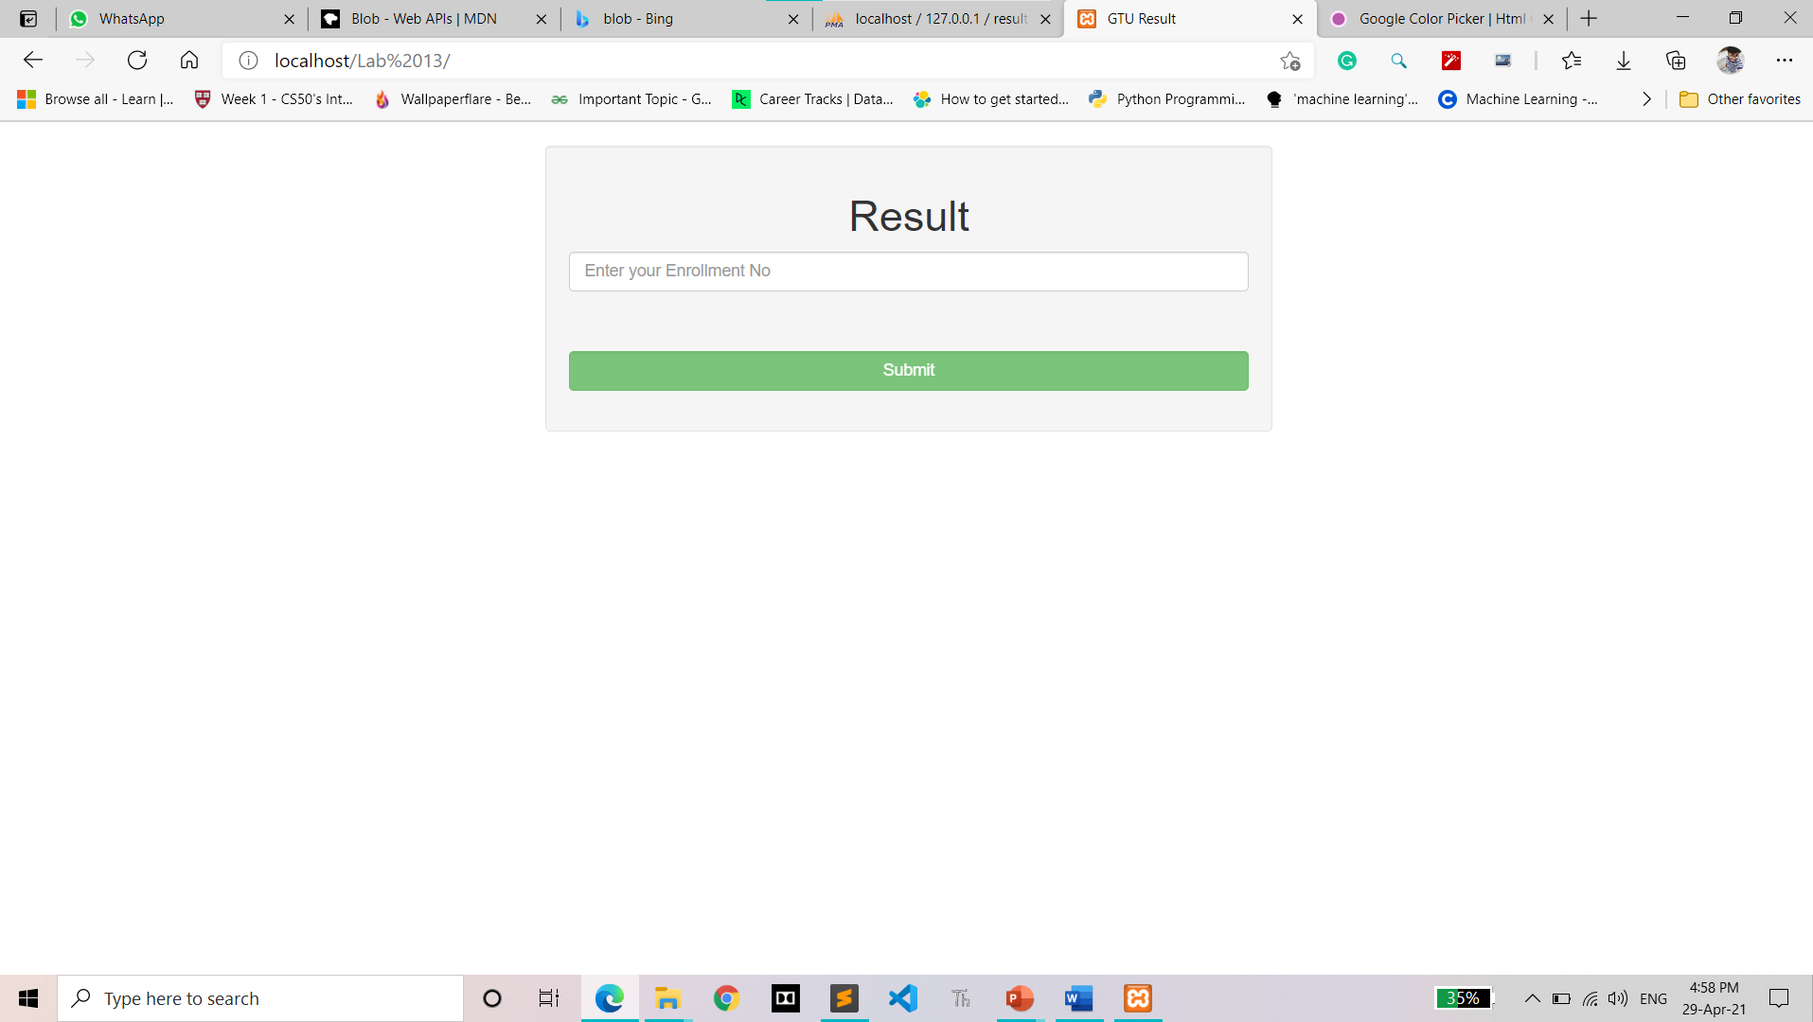

**User data can’t find for Enrollment**

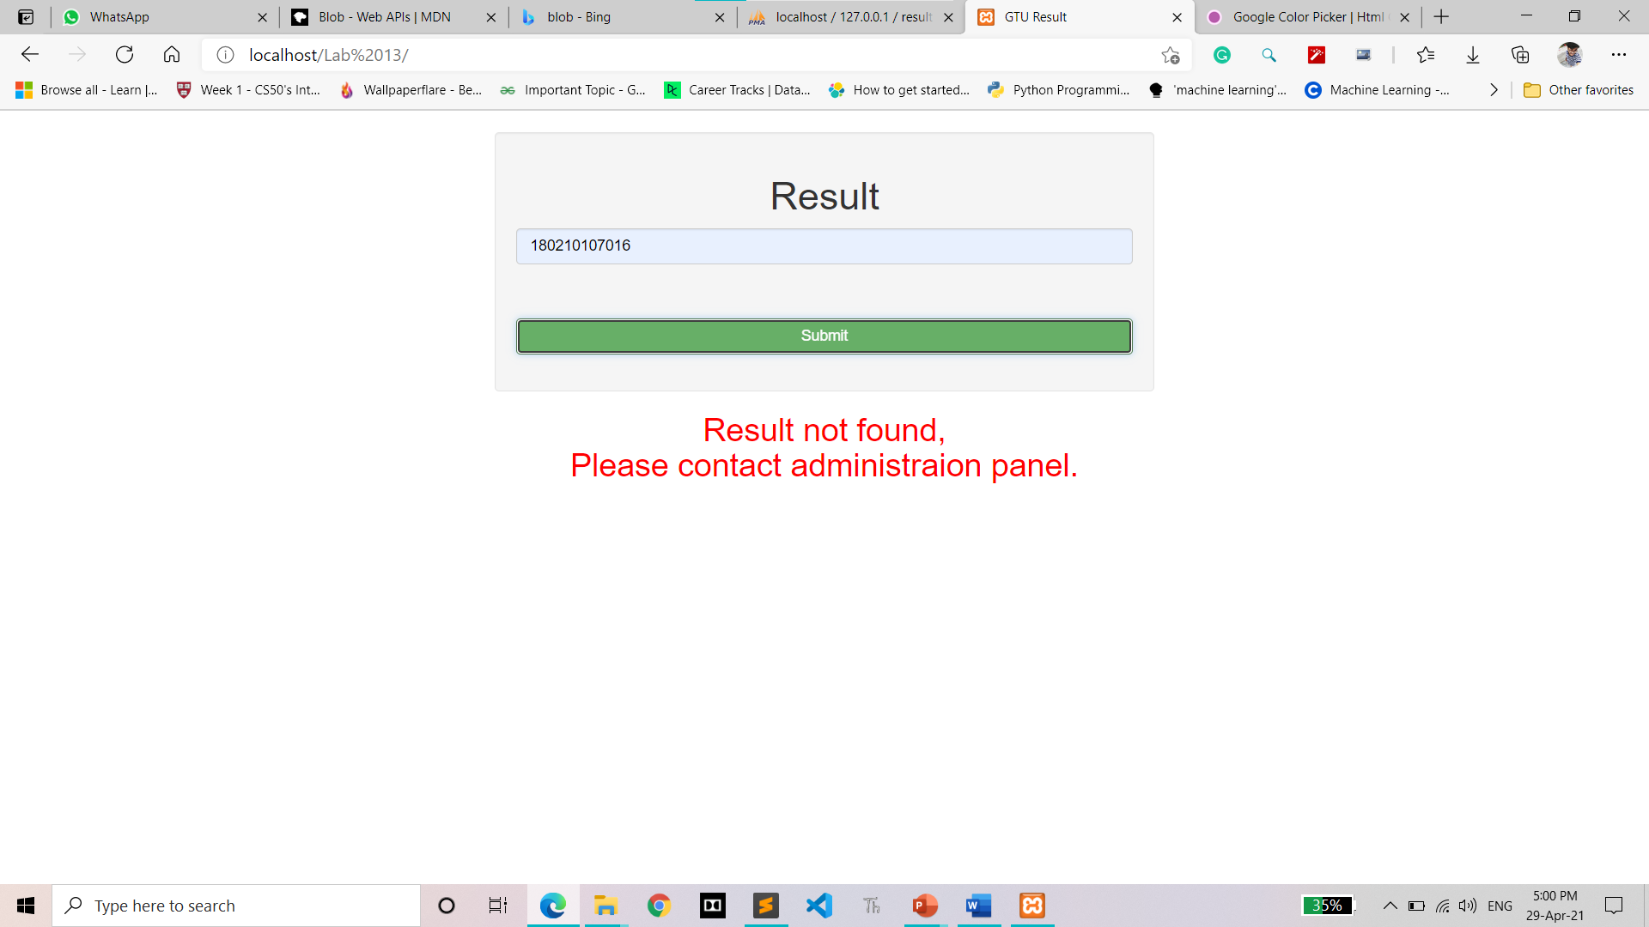

**Result of User**

